Task Jorvik: Essential

If you are confused with the annotations, here’s an example:

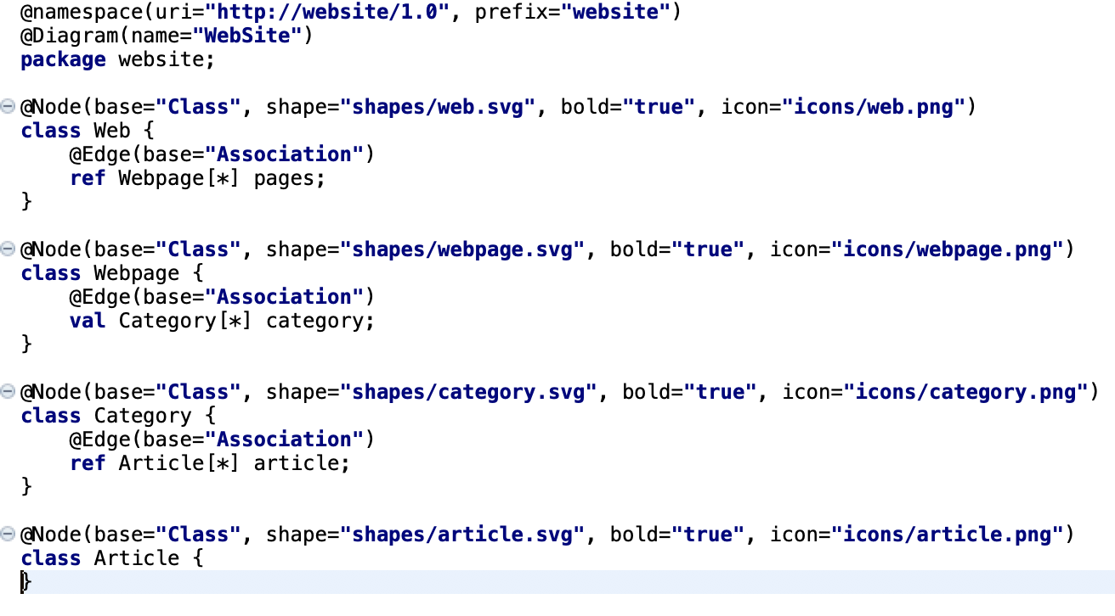

What you need to do next is to generate the .ecore model from the emfatic file. You may do this using Epsilon.

Once you have the .ecore file, you may right click -> Papyrus Profiles -> Generate Papyrus Project (New Folder). An Eclipse plug-in will be automatically generated for you.